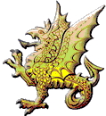 |  | 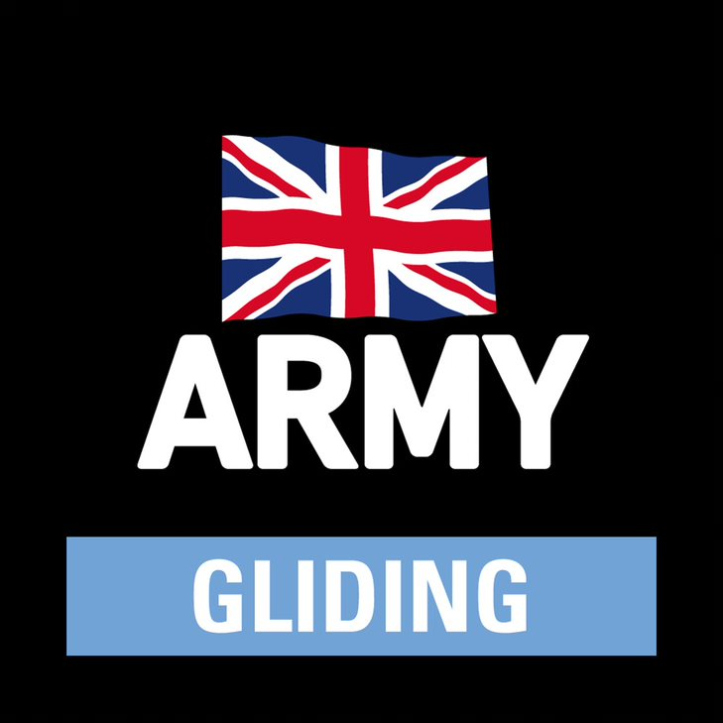
Gliding at Army Gliding Club (Wyvern) – Visitors
Please also look at the Army Gliding Club (Wyvern) website.
Club Launchpoint Telephone (only manned during flying hours): 07553 903739
Army Gliding Cub (Wyvern) AGC(W), is the largest gliding club within the Army Gliding Association (AGA). It provides gliding as a recognised sport and approved Adventurous Training activity to all current and retired servicemen, civil servants and civilians. It also provides air experience flights for all those interested in finding out about the thrill of gliding. All instruction is carried out by British Gliding Association (BGA) Instructors.
AGC(W) operates out of Upavon Airfield on the northern edge of Salisbury Plain, which is controlled by MoD Trenchard Lines. The club has 3 twin seat aircraft; 2 are ASK-21s, the other is a DG-1000.
This document aims to answer any questions you may have about gliding at Upavon Airfield.
Your club member liaison will inform you of the start time for your flying, generally around 1100 so please aim to arrive on time. Depending on weather, aircraft and instructor availability and number of visitors, you may have a wait until you fly. The aim is to keep this delay as short as possible. There is further information below, but is important that you bring with you suitable clothing for the airfield environment, food and any special drinks you may want. Picnics are very acceptable.
The address for the airfield is Upavon Airfield, Upavon, Wiltshire, SN9 6BE. Once at Upavon, follow the signs to MoD Trenchard Lines.

Important Information
Speed limit for road vehicles is 20 mph throughout the airfield.
Note: This is an active airfield and as such there may be aircraft landing or taking off at any time. When driving around the perimeter track (in particular at the North-East and South-West ends of the airfield) be sure to look out for aircraft on the approach. Gliders are white and silent – be sure to look thoroughly. DO NOT DRIVE IN FRONT OF ANY AIRCRAFT ON APPROACH, STOP AND WAIT FOR THEM TO GO PAST YOU. MAINTAIN THIS CAUTION THROUGHOUT.
Getting to the Airfield
- The address for the airfield is Upavon Airfield, Upavon, Wiltshire, SN9 6BE; once at Upavon, follow the signs to MoD Trenchard Lines. Alternatively, you can type “Upavon Airfield” into Google Maps.
- It is necessary to stop at MOD Trenchard Lines to inform them that you are there for gliding with the AGC(W). You will need to tell them your name and vehicle registration number. They may ask you to proceed to the guard room to collect a temporary car pass; or they may let you drive straight over to the airfield.
- Drive to the entrance to the airfield opposite MOD Trenchard Lines; see Figure 1. The barrier should be raised for you (by the Trenchard Lines guard now behind you) and you can drive in.
- Drive ahead between the hangars as shown in Figure 1 and turn on your vehicle hazard lights before you reach the end of the hangars.
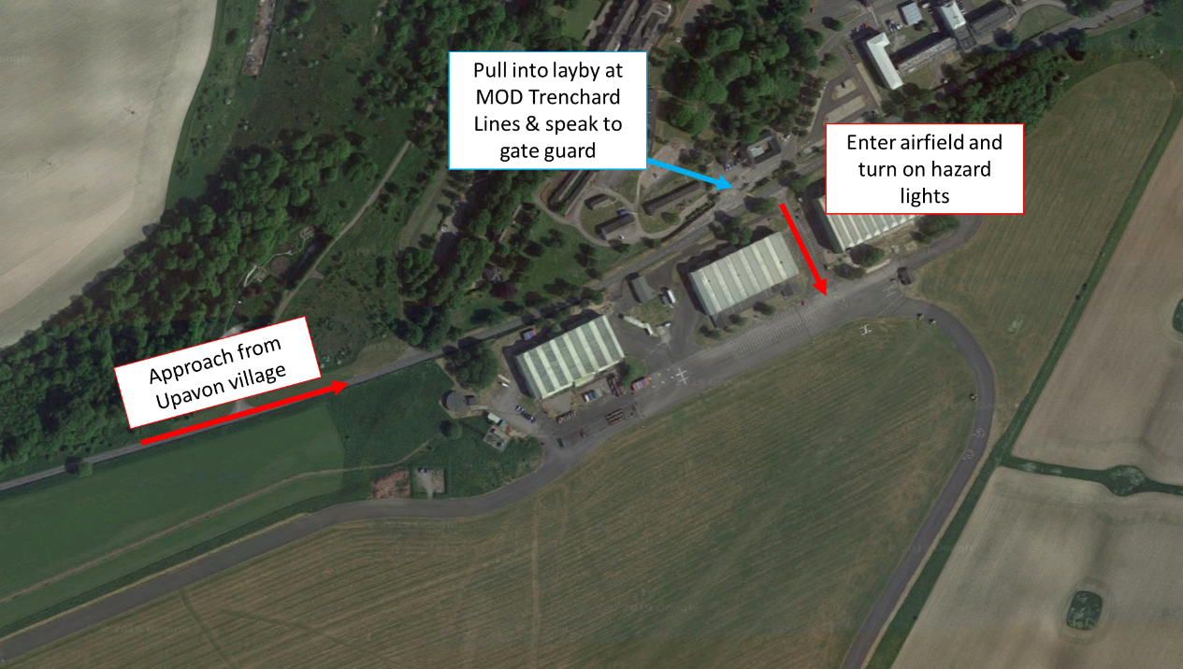
Figure 1: Access and entry to Upavon Airfield

- The airfield should be set up for gliding when you arrive. The arrangement will be different depending on the wind direction; and this will impact the actions you need to take on arriving:
If the wind is from the WEST:
- The caravan (launch control station) will be in front of you as you enter the airfield.
- Turn RIGHT and park in the area shown in Figure 2.
- From the parking area, face toward the caravan and look LEFT for approaching gliders. When certain there are no approaching gliders, walk across to the caravan KEEPING A GOOD LOOKOUT FOR GLIDERS ON THE APPROACH TO YOUR LEFT the whole time.
- If someone shouts for you to turn back or speed up, it is because they have seen a glider approaching. Do as they instruct. If unsure of the instruction, hurry to the nearest point (carpark or caravan).
- On no circumstances should you drive around the eastern end of the airfield as this is the approach for gliders. If you need to get to the south side of the airfield, you should continue round the north side and go down the west end, as shown in Figure 3. Note speed limit is 20 mph.
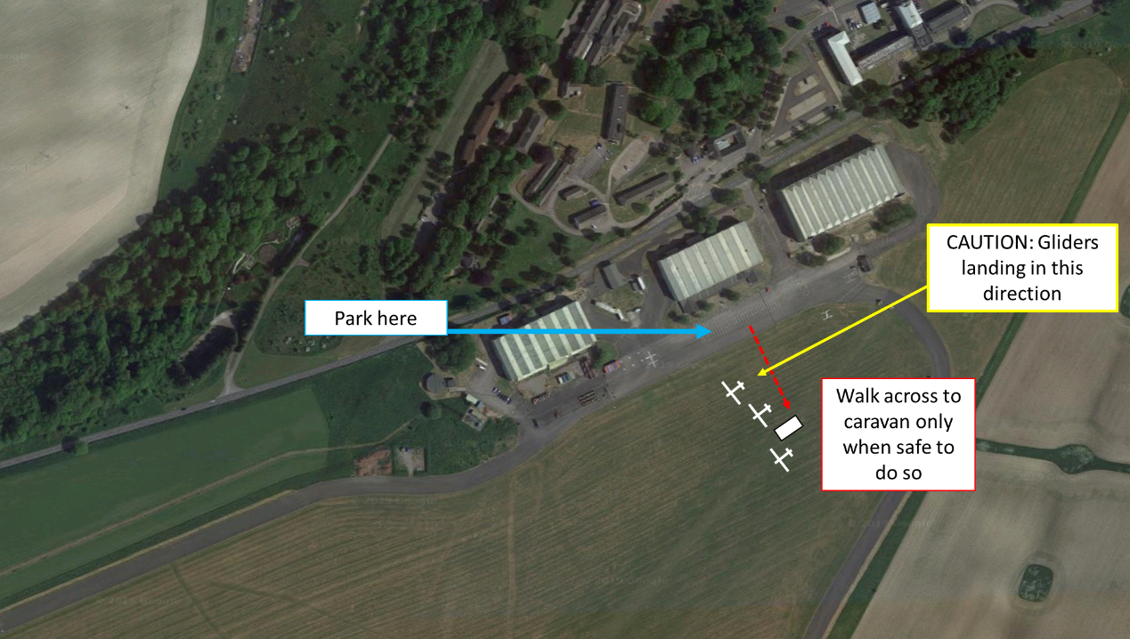
Figure 2: Where to park in westerly wind set-up
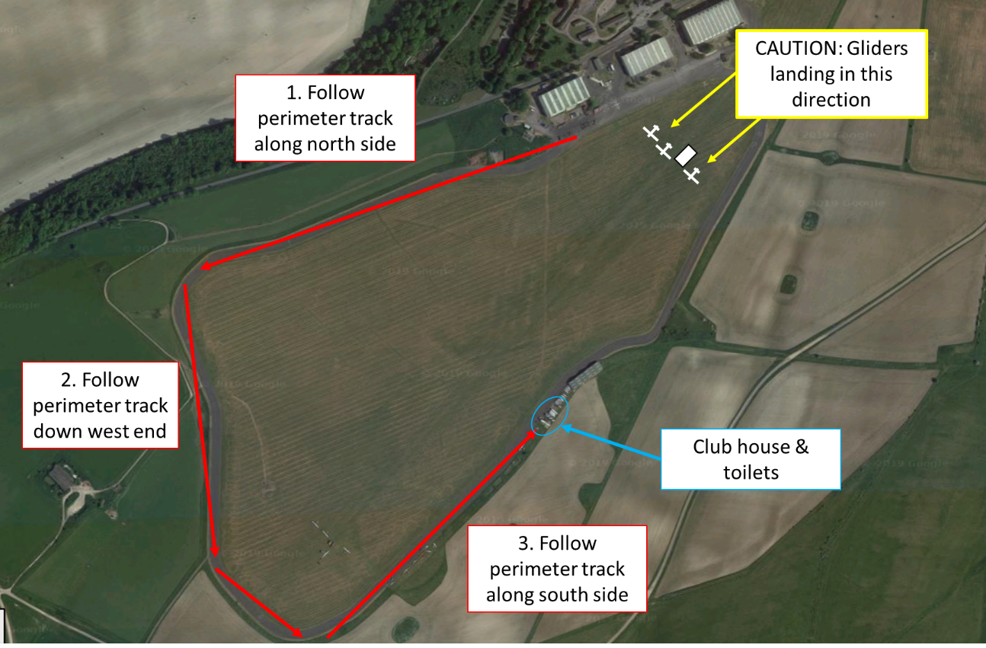
Figure 3: Driving round to south side in a westerly wind set-up
If the wind is from the EAST:
- The yellow winch will be in front of you as you enter the airfield.
- When the light on top of the winch is NOT FLASHING, turn LEFT and drive around the east end of the airfield behind the winch, continue on the south side, past the green hangar, grey containers and portacabins on your left, and park in the area shown in Figure 4.
- In no circumstances should you drive around the western end of the airfield as this is the approach for gliders. If you need to get to the north side of the airfield, you should return along the south side and go up the east edge. Note speed limit is 20 mph.
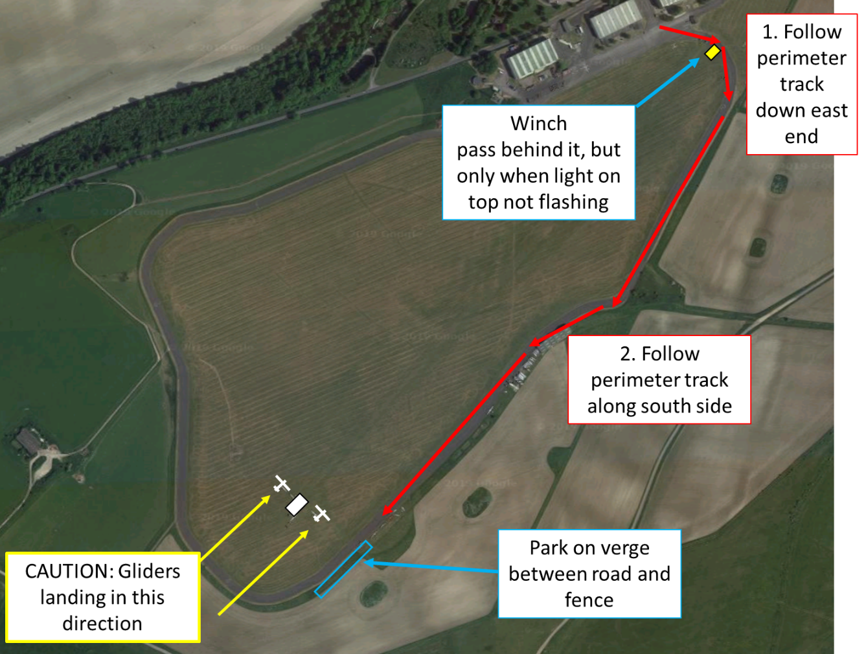
Figure 4: Where to park in easterly wind set up
Once arrived, ask for the Duty Instructor or Duty Pilot to let them know you have arrived as he/she will be organising the flying rota and will provide an appropriate brief on what is going to happen and for your safety.
Other Information
Insurance: You must not fly without completing a Temporary Membership Form as this is your insurance – please complete it. Your details will be entered into the Glidex Logging system.
Safety: You will be given a safety brief for your safety on the ground. However, please ensure vigilance at all times and ask if there is anything you are unsure of. If someone shouts, it will be due to a safety concern. It is so important to LOOK before you walk away from the caravan – even if you are just walking to a glider on the ground.
Weight Limits: Our gliders have a maximum passenger weight limit of 103 kg / 228 lb (16 st & 4 lb) – this includes wearing a parachute (approx. 4.5 kg / 10 lbs). This is for aircraft controllability so it is important not to exceed it; you may therefore be asked to step on the scales. Some people (e.g. children) may be too light to fly in the front seat (again for controllability) but we can put them in the back seat with instructor in the front.
Size: Some people may be too small to be secured by the aircraft harness so won't be able to fly - but do ask us to check. Very tall (over 6'4'') people may not fit under the canopy (but depends on other anthropometrics).
Cost: The price of Temporary Membership is £25 for service personnel and their family, £50 for MOD personnel, and £65 for civilians. This can be paid in cash or by cheque to ‘Army Gliding Club (Wyvern)’ (unfortunately we cannot accept card payments). This membership will allow you either two flights up to approx. 10 minutes or one longer flight – this depends on the weather.
Flights: Temporary membership allows for 2 flights or 1 soaring flight. If time permits, people can have more but will be charged at normal club launch and soaring fee rates.
Clothing: It is best to judge the weather during the day. The weather tends to be slightly exaggerated at Upavon Airfield. So a breeze at home could mean it is quite windy and therefore cooler at the airfield. Layers are the best option, and bring a waterproof / windproof jacket. Sunglasses, suncream and sunhat may be required (you could be sat under a Perspex canopy for a while). Trainers are fine but keep in mind if it has been raining during the day you could end up with wet feet.
Toilets: Are available at the ‘Gliding Hub’ shown in Figure 3.
Food: There is no food available to buy at the club. Tea and coffee is available for a small charge. Please bring whatever you may require.
Drinks: Keep hydrated – Bring water / other soft drinks to drink during your visit, and we’d be delighted to welcome you to our clubhouse bar after the flying for drinks and tales of daring...

If you have any more questions, please contact your club member liaison.

